**Demonstrate how Selenium web driver is installed and integrated in Eclipse.**

There are two ways to install selenium and integrate it in eclipse

We are going to choose the easy one by creating a maven project by clicking file>maven project.

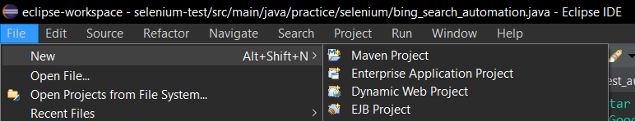

Select maven-arch type-QuickStart



Provide a name and click on finish to create a maven project

So that selenium is included in the maven dependencies by default.

We need to import selenium into our java code

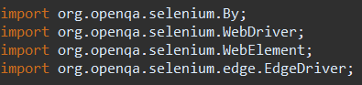

Go to pom.xml and add selenium dependencies

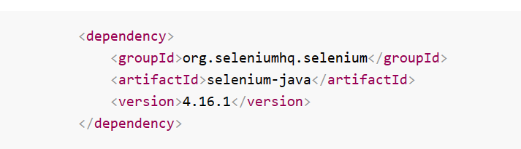

And also add junit dependency

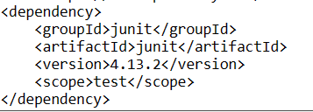

Download the driver for your required browser and make sure you download the correct version for based on your browser version.

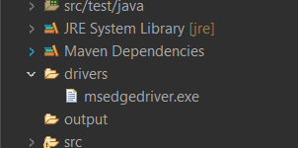

Finally we can write java code to open a web browser and start testing.